**1: In all graphs and cost analysis, you can remove all the decimals.**

**9: When analyzing outsourcing using the Team based financing model, what financial metric does knowledge loss extend/negatively impact?**

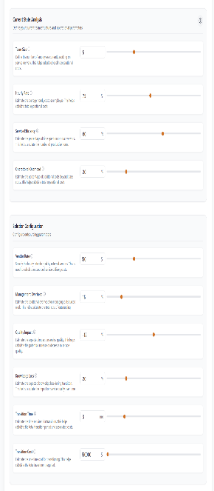

With ticket based model, it is supposed to extend the hours per ticket,

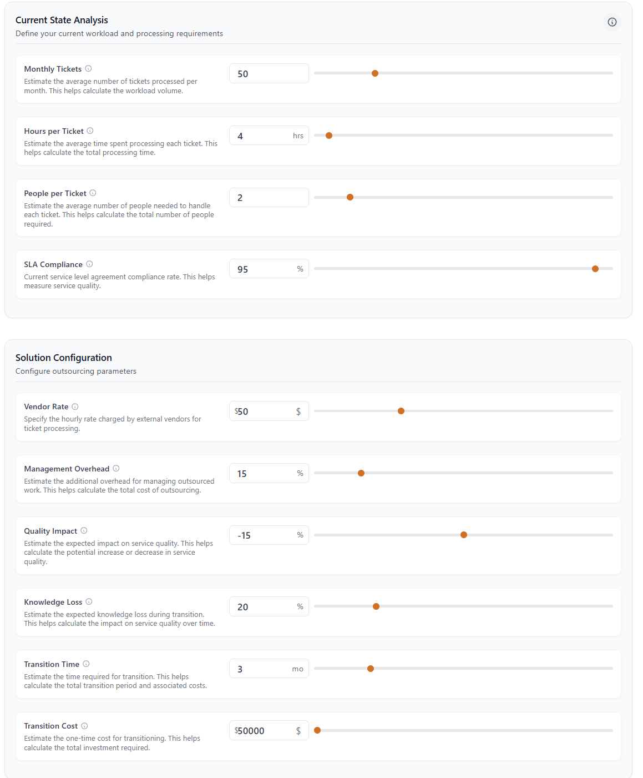

but that field does not exist in the team based, so is it in use? Or should we add “average resolution time as a field for team based model?)

**11: Monthly cost for platform ROI projection (find break even point) works wrong when the projection is negative, and it is capped at the cost of monthly maintenance.**

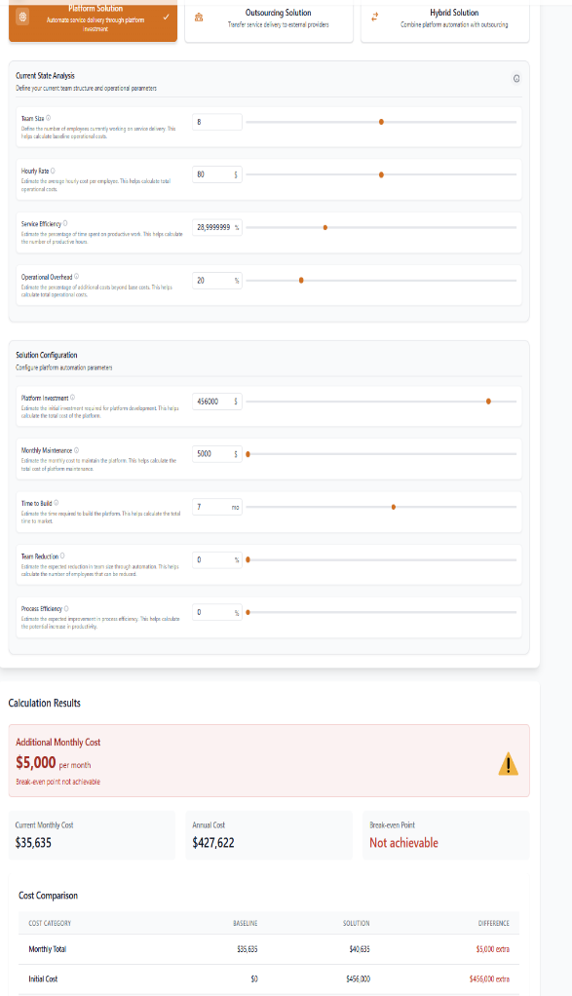

In the example below, I set team to 10 people, 100usd hourly rate, service efficiency 100%, overhead 0%.

The results indicate to me that the additional monthly cost is only the monthly maintenance cost, but because we can never break even on the extra investment we also make a huge loss which is not visible anywhere. Is it possible to fix this?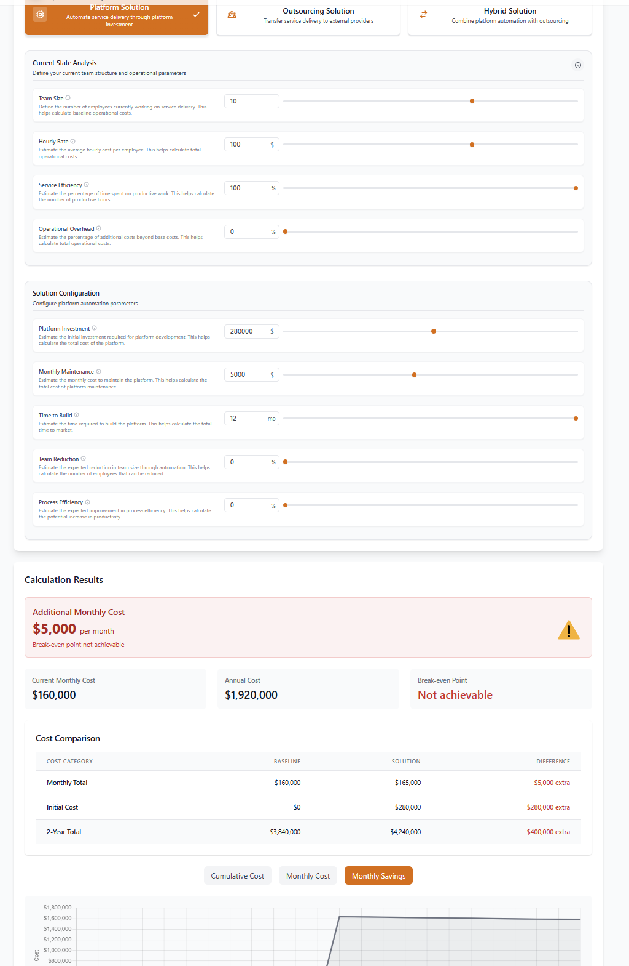

**12: Something funky about outsourcing math (I think)**

There’s something off about the math around outsourcing, I think. I think it might be related to the management overhead slider? It has a very high impact on the projected monthly saving. Maybe we need to rework the slider scale/range or something else. Or maybe it is correct but we need to change the name of the slider? I was thinking this is about how much management overhead is necessary to maintain a decent quality of the outsourcing. But is the 20% in relation to the original 10 people on the team costing 100usd / hour? Or is it in relation to the new cost and new team size?

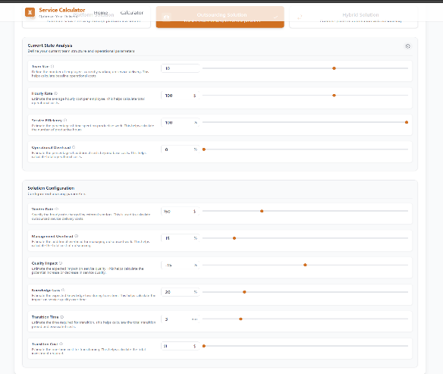

Compare 0% vs 25% overhead

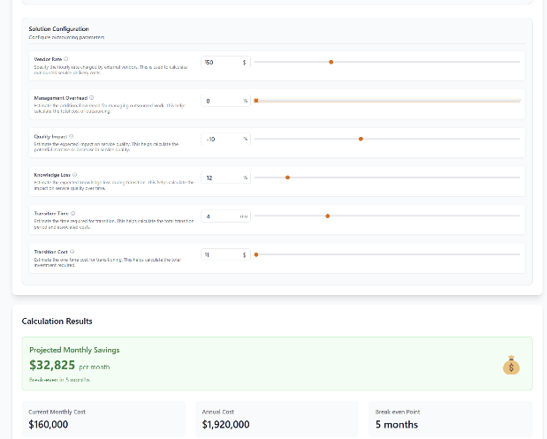

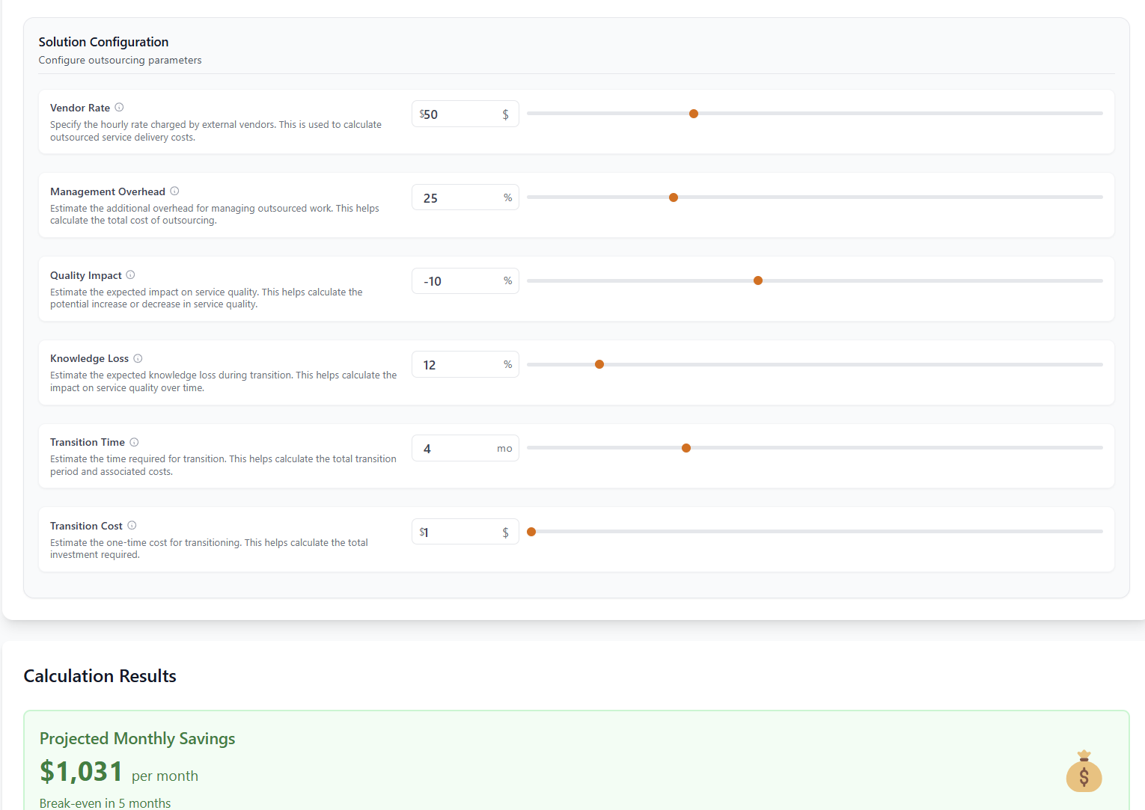

**16: Copy changes**

Change from team size reduction to Time freed up (copy change) can be done later

Change mode names: Build Business Case, Define Platform Budget, Reveal Team Dependency Costs.

**Rename Service Calculator to: Operations Costs Planning**